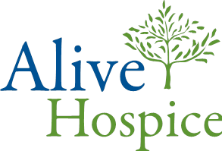

Documentation of 2021-2022 Influenza Vaccination Status

Alive Hospice, in response to CDC guidelines, has recommended that I receive an influenza vaccination in order to protect myself and the patients that I serve.

I acknowledge that I am aware of the following facts:
- Influenza is a serious respiratory disease that kills an average of 36,000 persons every year.
- Influenza vaccination is recommended for me and all other health care workers to prevent influenza disease and its complications including death.
- If I contract influenza I will shed the virus for 24-48 hours before influenza symptoms appear. My shedding the virus can spread influenza disease and its complications including death. The shedding can continue up to 7 days.
- I understand that the strains of virus that cause influenza illness change almost every year. Annual vaccination is recommended.
- I cannot get the influenza disease from the influenza vaccine.
- The consequences of my refusing to be vaccinated could endanger my health and the health of those with whom I have contact, including my Alive Hospice patients, my coworkers, my family and my community.

I may choose to decline the flu vaccine. I understand that being vaccinated is one way to protect the health of our patients. I understand that I may be contagious before symptoms begin. I have been instructed not to come to work if I have any symptoms of the influenza including fever, cough, sore throat, headache, chills, muscle aches and fatigue.

________________________________________________________________________
Printed Employee Name Employee Signature Date

Team or Location _____________________ Job title___________________________

Choose one of the following:
-  I was vaccinated at alternative location
-  I decline. Allergic to ingredient or medical contraindication______________
-  I decline. Other, short explanation* _________________________________

*If you choose to be vaccinated later please update your status

